(NASDAQ: ABNB) Airbnb
Current S/P (9/24/2026): $151.39 | Mkt Cap: $88.19B | Target Price: $122 | Implied Return: 20% | R/R: 2:1 | SI: 3.59%
Investment Thesis: We recommend a SHORT on ABNB with a target price of $122 on three points: (1) Reserve Now Pay Later (RNPL) began rolling out in 2025 and the market is not fully pricing the resulting increased cancellation rates. (2) 2026 World Cup surge masks decelerating nights. (3) Operating leverage causes revenue drops to drive outsized margin compression, and AI-driven margin growth is overstated. These factors will result in weak Q3 and Q4 guidance across nights, revenue, and margins leading to stock underperformance.
Market/Variant View: The market is pricing ABNB with 4Q26 nights at a growth rate of +11.45% (range of 9.9% to 12.5%) in line with management’s “low double digits” guidance. Guidance matters more than revenue as ABNB has fallen 9 of 19 times after beating revenue.
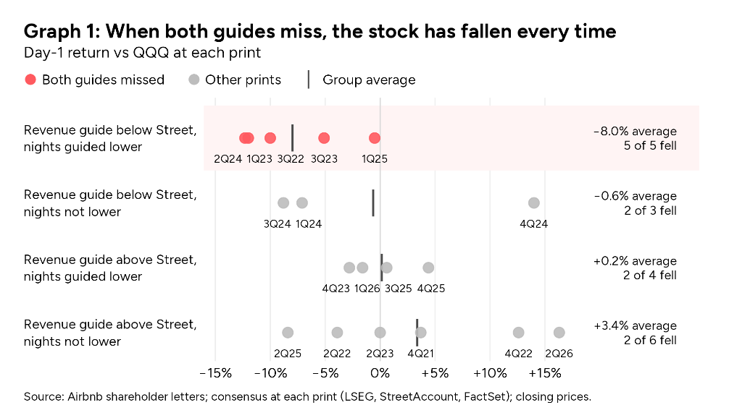
When next quarter guide lands below the street and nights are guided down, the stock has fallen 5 of 5 (Graph 1). Our variant view is a guidance differential: we price ABNB nights at 9.89% YoY on 3Q26, 8.12% 4Q26, and 8.21% 1Q27. Consensus forecasts 11.53%, 9.93%, and 9.62%. Therefore, we expect 3Q26 nights and revenue guidance to signal low growth confidence, and 4Q26 nights and revenue will come below estimates. After 5 consecutive guides above consensus, we put the 4Q26 guide below consensus, forecasting stock underperformance after Q3 and Q4 earnings as nights, revenue, and margins are guided down.
Company and Industry Overview: ABNB divides revenue into four geographic segments: North America (42%); Europe, Middle East, and Africa (EMEA) (39%); Latin America (10%); and Asia Pacific (APAC) (9%). ABNB competes primarily with Expedia’s Vrbo, Bookings.com, as well as major and boutique hotels.
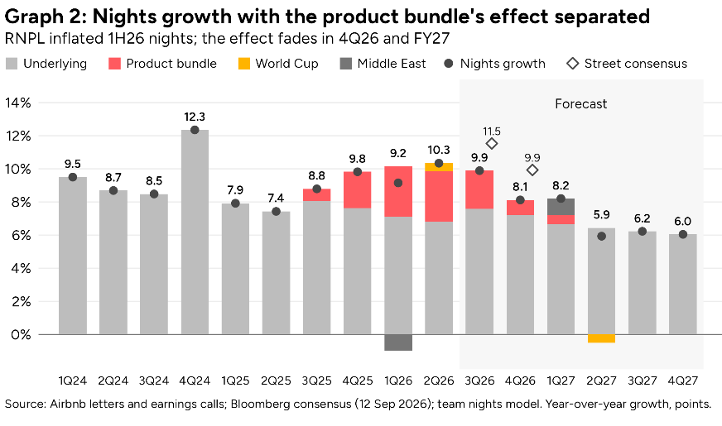
Thesis 1 – RNPL Rollout-Driven Cancellation Rate Elevation Has Been Hidden: Airbnb was slowing (nights +9.1% in 1H24, +7.7% in 1H25) when it launched RNPL in August 2025 ($0 at booking, payment due just before free cancellation ends), then added 14-day free cancellation and a 15.5% host-only fee in order to reduce booking friction. Management credited the three with >2pts of YoY nights growth in 4Q25 and ~3pts in 1Q26 (RNPL ~1.6pts by our split). Reported nights hit +9.7% in 1H26, but underlying nights growth fell to ~7%. RNPL rose from ~4% of GBV (3Q25) to 20% in 1Q26, then "over 20%" in its first full global quarter. Management then stopped quantifying the effect of RNPL. RNPL bookings cancel more. Cancellation rate is historically ~16%, but after RNPL was implemented, management stated cancellation rates grew from 16% to 17% (3Q25 à 1H26), implying an RNPL cancellation rate of ~22%, 1.38x as often as normal bookings. Guests cancel for free until they pay, just before check-in, so bookings count immediately. However, about half the cancellations hit a later quarter: the nights lift for RNPL showed up in 1H26, the cancellations keep arriving through 2H26. As RNPL grows (eligibility widened in July, increasing RNPL as a % of GBV), those cancellations cost 0.9pt in 3Q26, just as the US launch cancellations slow growth. The bundle falls from ~3pts to ~1.4 nights growth contribution, then ~0 in 4Q26: leading to a bear case ~7% nights growth vs the Street's +11.53%.
Thesis 2 – Nights and ADR Will Print Below Consensus Due to Temporary and Structural Weakness: Consensus nights YoY is +11.5% (148.9m) for 3Q26 (in-line with management guidance), and +9.9% (134.0m) for 4Q26. Our Q3 and Q4 nights model projects +9.2% and +8.1% YoY based on three independent sources. First, a review-date stays index built from 75 million Airbnb reviews, adjusted for 15-16% attrition. Comparing the reviews at point-in-time between two annual data sets, we calculated a 5.99% growth for the cities covered. We then utilize a two-parameter model calibrated on historical data pre-RNPL to reconcile covered and uncovered region growth to estimate Airbnb’s global growth, giving an estimated 8.9% for 3Q26. External data from CoStar STR, Eurostat, BLS, INE tourism series, and EUROCONTROL for EMEA flights also confirm the reviews data findings. Finally, using SimilarWeb we map Airbnb.com traffic against gross bookings over 12 quarters providing another estimate of Q3 growth. All methods point to an 8.0% - 9.9% YoY range for 3Q26 and a final estimate of 9.2%. The three-bundle contribution is backed out of the final outputs based on Thesis 1, resulting in reductions of 0.8pts in 4Q26, 1.1pts 1Q27, and 1.6pts from 2Q27 onward, arriving at a final FY27 nights growth of 6.6%, versus the market expected 8.9%. On price, the Street's 3Q26 ADR ($177.06) is what a simple currency straight line gives ($177.07); our FX estimate with the better point-in-time record determined FX is a −0.4pp drag, not +0.4pp: $175.66. We forecast ADR then slows to +1.0% ex-FX by 1Q27: the bundle's ~1pt ADR lift nets out with cancellations, pricing reverts to its 2023–26 average, and North America's slowdown tilts mix to cheaper regions (−1.6pp). These factors will drive management to revise guidance downward.
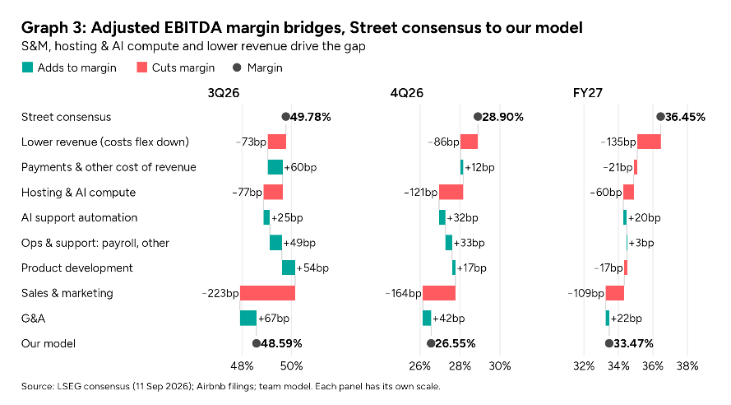
Thesis 3 – AI Driven Margin Expansion is Overstated and Revenue Declines Compound Compressing Margins: The Street's expected FY27 margin (36.4%, up from 35.6%) needs cost growth to slow from ~15% to 10%, the slowest since the IPO, and AI is the bull case for it. The filings show the savings are small and already spent. The 2Q26 10-Q credits AI with $17M of lower support costs in a quarter when S&M rose $184M. Management plans to "reinvest most of these efficiencies into marketing, product and technology" (4Q25 earnings), and its 2026 guide absorbs "a material increase" in AI spend. In our FY27 bridge, hosting and AI compute take 59bp of margin while AI support savings return 20bp. S&M spending is inelastic to revenue. S&M has outgrown revenue for nine quarters (16.5% of revenue in FY23, 23.9% in 1H26); when revenue growth slowed from 18% to 10%, S&M growth rose from 16.5% to 20%. Therefore, consensus S&M assumptions are unrealistically optimistic. Our forecasted 2.5% lower FY27 revenue falls through: even if costs follow the Street's own plan and fall with revenue at the historical rate, FY27 margin is 35.4% and FY26 35.4%, below the "at least 35.5%" management floor. On our cost, FY27 is 34.0% ($5.24bn EBITDA vs $5.77bn). We expect management to revise margin expectations downward in 3Q26 and 4Q26 earnings, adding to the downward stock pressure.
Catalysts: We forecast Nights to come weaker than consensus in 3Q26 earnings, and management to guide 4Q26 nights to “decelerate” with revenue and margins guidance coming in lower than the Street. Post Q3 and Q4 earnings we expect the market to model down Airbnb’s short-term and long-term growth, realizing our thesis.
Risks & Mitigants: Risk 1: Management cuts spending, driving EBITDA and EPS upwards. Mitigant: Management’s narrative states spending is needed to drive growth. Spending cuts indicate weakness which damages the current narrative and plays into our thesis. Risk 2: Management doesn’t cut guidance in 3Q26 earnings, either hiding evident Q4 weakness or due to lack of visibility. Mitigant: Q3 nights will come below consensus. Even if guidance doesn’t miss, upward revisions are unlikely reducing upside risk, and the thesis is highly likely to be realized in 4Q26 earnings.
Valuation: On our numbers ABNB trades at 16.81x NTM EBITDA, while consensus numbers imply 14.93x. Assuming the market multiple compresses as the strong growth narrative weakens and margins come down, on our numbers we value ABNB at 13.43x NTM EBITDA, close to historical trough multiples, implying a target price of $122.

